1. Change initial year to 2017, showing

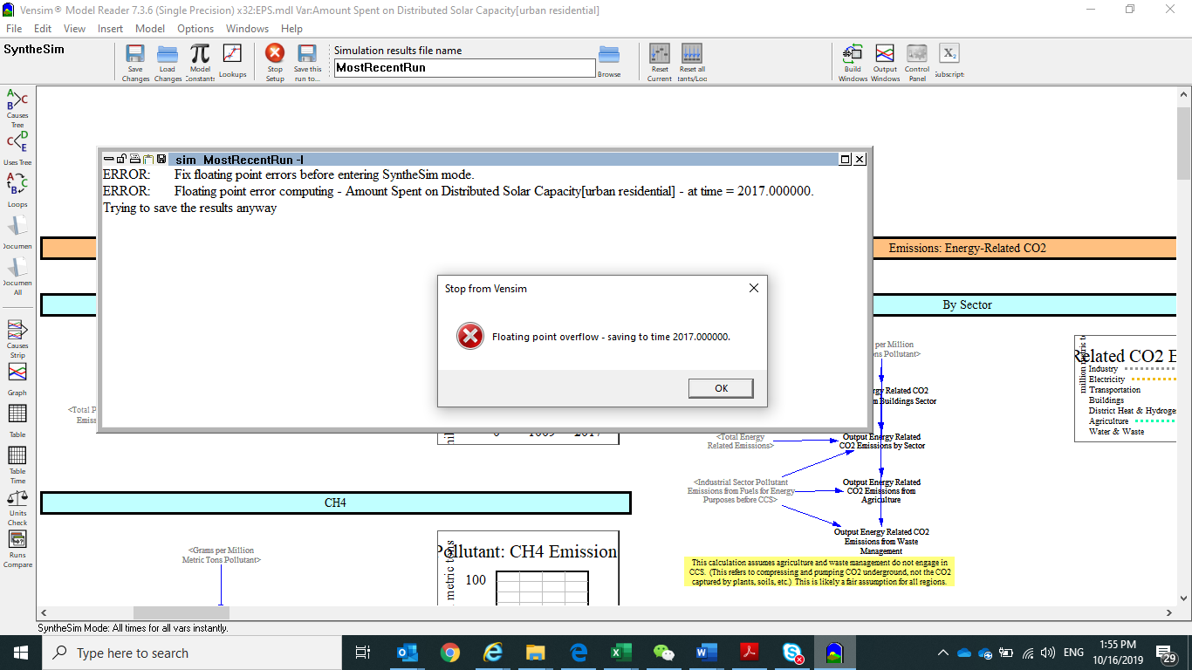

1. HK has no biofuel electricity, how to remove biomass generation?
2. There are still petrol electricity generation in BAU and policy scenario, change dispatch rule for petrol from 1 to 2, but still has petrol electricity generation
3. Coal electricity still exist after 2038 while 1.0 coal is gone after 2038, why?
4. Comparing 2018 results, I’m checking the reasons

|  |  |  |
| --- | --- | --- |
| 2018 | 1.0 | 2.0 |
| Total (energy) | 37 | 42 |
| * Production |  |  |
| Electricity generation | 28 | 33 |
| Building | 2.2 | 2.2 |
| Transport | 6 | 5.6 |
| Industry | 1.3 | 0.3 |
| * Consumption |  |  |
| Building | 28.5 | 33.4 |
| Transport | 6.2 | 5.7 |
| Industry | 1.9 | 2.1 |

1. Can we set fuel mix for electricity import and export in policy scenarios? Now it seems we it is same with BAU

|  |  |  |  |  |  |  |
| --- | --- | --- | --- | --- | --- | --- |
|  | battery electric vehicle | natural gas vehicle | gasoline vehicle | diesel vehicle | plugin hybrid vehicle | nonroad vehicle |
| LDVs | 10207 | 18138 | 535216 | 11414 | 46 | 0 |
| HDVs | 44 | 4309 | 0 | 16812 | 0 | 0 |
| aircraft | 0 | 0 | 0 | 0 | 0 | 0 |
| rail | 0 | 0 | 0 | 0 | 0 | 442 |
| ships | 0 | 0 | 0 | 0 | 0 | 10684 |
| motorbikes | 34 | 0 | 53719 | 0 | 0 | 0 |

Cross check if motorbike is taxi

SYVBT is start year vehicle